
NAME: DAVID OKOTH
ADM NO: BSCCS/2024/74331
COURSE: BACHELOR OF COMPUTER SCIENCE
DEPARTMENT: COMPUTING AND INFORMATICS
UNIT CODE: BIT3208
UNIT NAME: ADVANCE WEB DESIGN AND DEVELOPMENT
LECTURER: NYORO MICHAEL
PROJECT DETAILS
Project Title: EMPLOYEE MANAGEMENT SYSTEM
Selected Technologies: PHP and SQL, CSS, HTML, etc
Github link: https://github.com/okothdvdodhiambo-create/Employee-management-system

Table of Contents
WEEK 1: Local environment setup………………………………………………………………………………………………..3
XAMPP Installed already………………………………………………………………………………………………………………3
Figure 1: Xammp…………………………………………………………………………………………………………………………..3
Figure 2: Localhost running……………………………………………………………………………………………………….3
Figure 3: Database connection…………………………………………………………………………………………………..4
GitHub link:………………………………………………………………………………………………………………………………..4
WEEK 2:UI/UX and Design Foundations……………………………………………………………………………………………..5
Title: User Interface Planning and System Design…………………………………………………………………………..5
Wireframe……………………………………………………………………………………………………………………………………..5
Figure 4: wireframe…………………………………………………………………………………………………………………...5
Project proposal summary………………………………………………………………………………………………………….5
Figure 5: Dashboard…………………………………………………………………………………………………………………..6
WEEK 3: Document Object Model practised……………………………………………………………………………………6
Frontend interaction and Backend foundation……………………………………………………………………………..6
Figure 6: Button………………………………………………………………………………………………………………………..7
Figure 7: PHP practise………………………………………………………………………………………………………………..7
Figure 7: Database connection script…………………………………………………………………………………………7
Figure 7: GitHub repository……………………………………………………………………………………………………….8
WEEK 4: Server-Side Components…………………………………………………………………………………………………..8
Figure 8: Modular Folder structure……………………………………………………………………………………………8
Figure 9: Php form procesing…………………………………………………………………………………………………….9
Figure 10: Update database connection…………………………………………………………………………………….9
Student Reflection:……………………………………………………………………………………………………………………9
WEEK 5: DATABASE COMPONENT………………………………………………………………………………………….10
Implementing Secure Database Management and Access Control………………………………………….10
Figure 12: Secure server Logic………………………………………………………………………………………………..10
Figure 11: Database scheme expansion………………………………………………………………………………….11
Summary on what is in the project…………………………………………………………………………………………11

WEEK 1: Local environment setup

XAMPP Installed already

Figure 1: Xammp

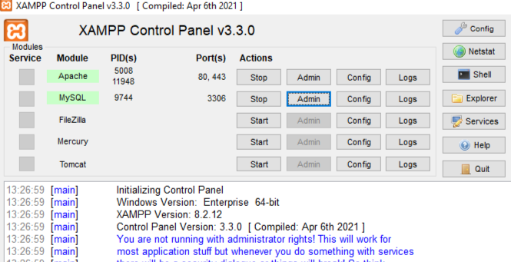

Figure 2: Localhost running
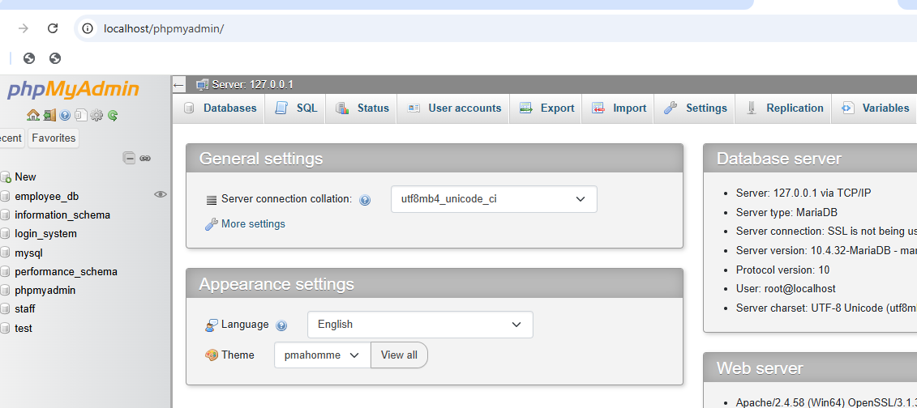
Database connection success http://localhost/phpmyadmin/index.php?route=/sql&db=employee_db&table=employees&pos=0
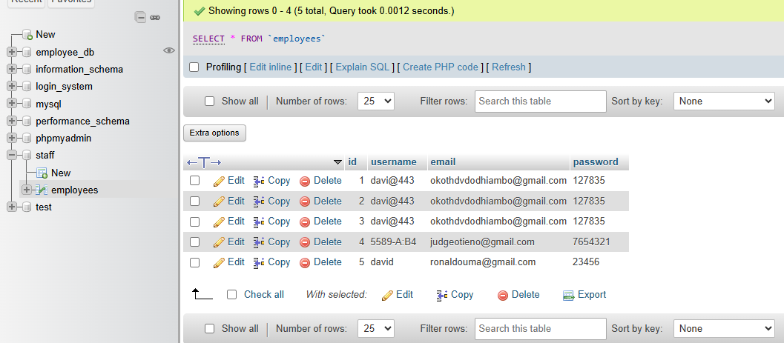

Figure 3: Database connection
GitHub link: https://github.com/okothdvdodhiambo-create/Employee-management-system

WEEK 2:UI/UX and Design Foundations

Title: User Interface Planning and System Design

Wireframe
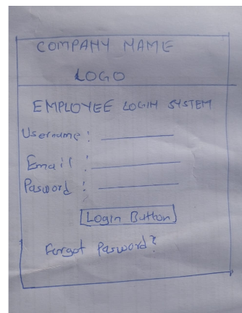

Figure 4: wireframe

Project proposal summary
Project: Employee Management System
A web-based system used to manage employee registration,
login, records, and reports.

Figure 5: Dashboard
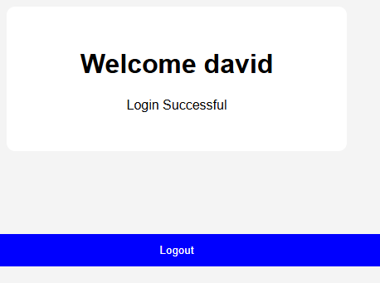

WEEK 3: Document Object Model practised

Frontend interaction and Backend foundation

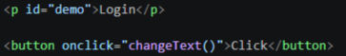

Figure 6: Button
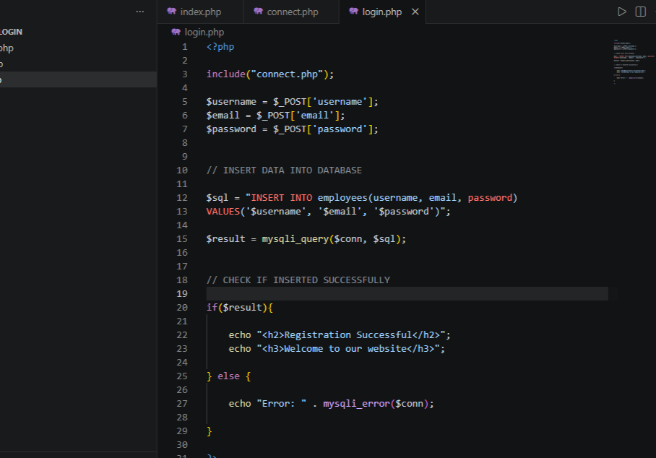

Figure 7: PHP practise
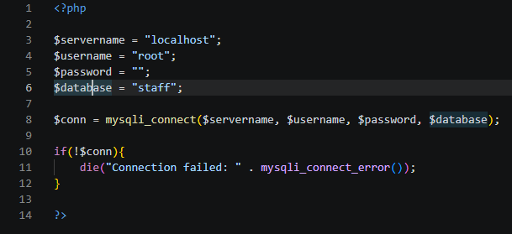

Figure 7: Database connection script

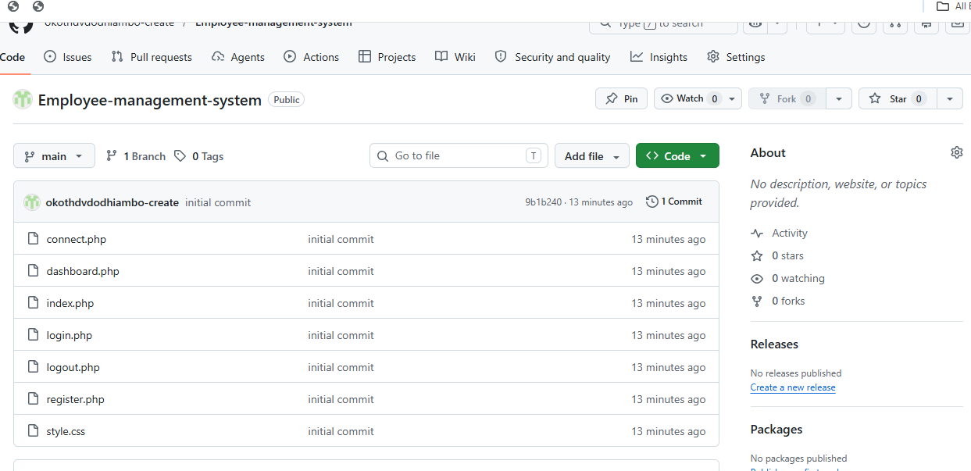

Figure 7: GitHub repository

WEEK 4: Server-Side Components
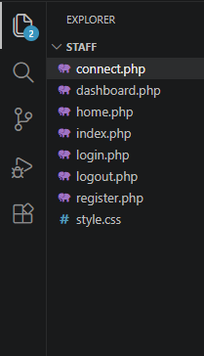

Figure 8: Modular Folder structure

Login form validation practical, Email Validation, Password checking,

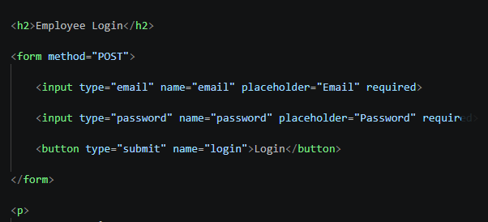

Figure 9: Php form procesing
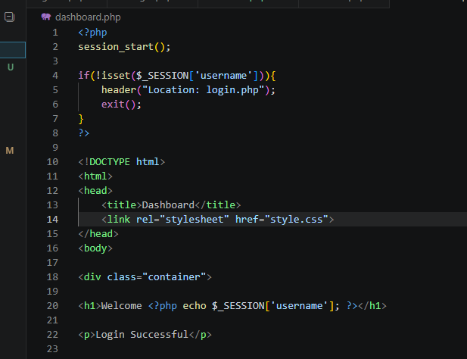

Figure 10: Update database connection
Student Reflection:
Week 1 to 4 marked a significant shift in the TechStore architecture, moving from standalone scripts to a more structured and professionally organized backend framework. Through the creation of an includes/ directory, the database connection configuration was effectively separated from publicly accessible files, enhancing security. I used PHP $_POST variables to process form submissions safely and linked the user authentication mechanism with active server-side sessions ($_SESSION). In addition, I configured a dedicated week4db database to isolate the project's data, ensuring effective version management and reliable rollback options.

WEEK 5: DATABASE COMPONENT

Implementing Secure Database Management and Access Control

Figure 12: Secure server Logic

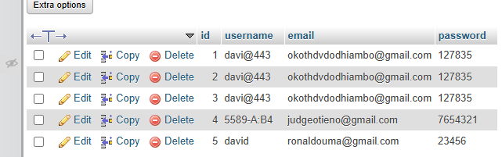

Figure 11: Database scheme expansion
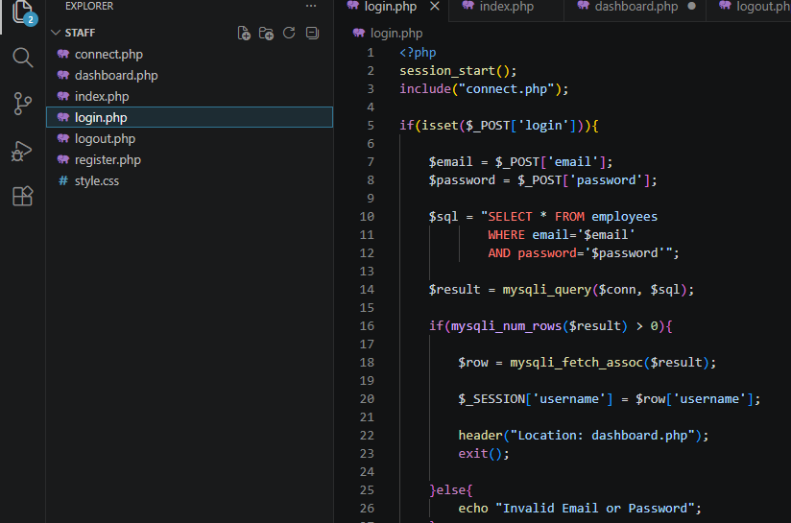

Summary on what is in the project
This is an Employee Management System system that includes login nd registration forms, database connection, and basic form validation. Wireframes and GUI mockups were created to plan the user interface and navigation structure. JavaScript used for input validation and interactive features, while PHP handled backend processing and database connectivity.
GitHub account Link https://github.com/okothdvdodhiambo-create/Employee-management-system

